**INDEX**

|  |  |  |
| --- | --- | --- |
| S No | Title | Page No |
| 1. | Virtual machine | 2 |
| 2. | Deploying in azure VM using cmd | 3 |
| 3. | Creating storage using blob | 7 |
| 4. | Deploying directly with github | 9 |

# **Virtual machine:**

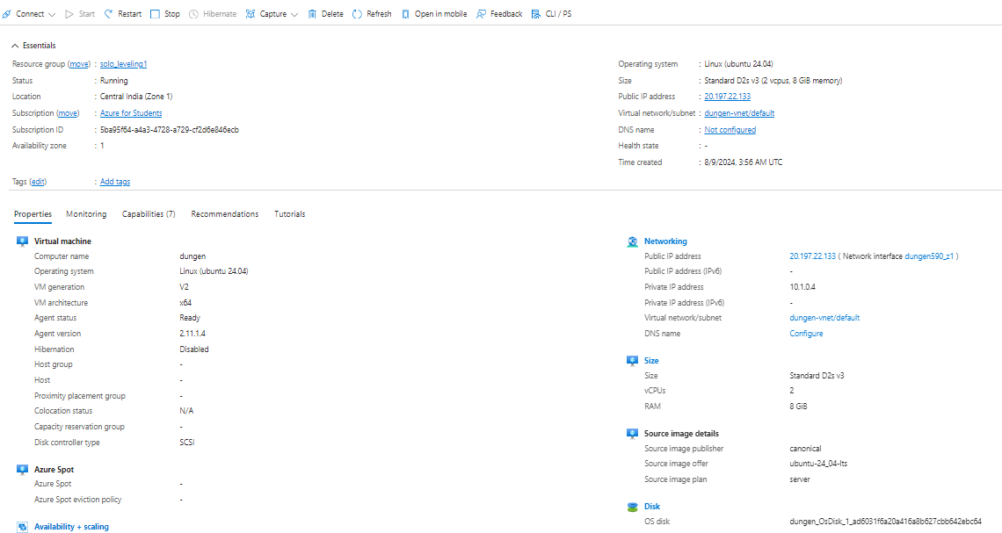

# **Deploying in azure VM using cmd:**

# Commands:

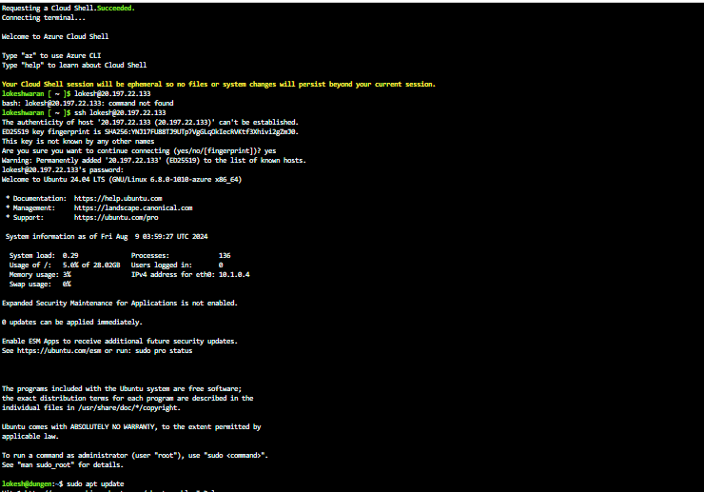

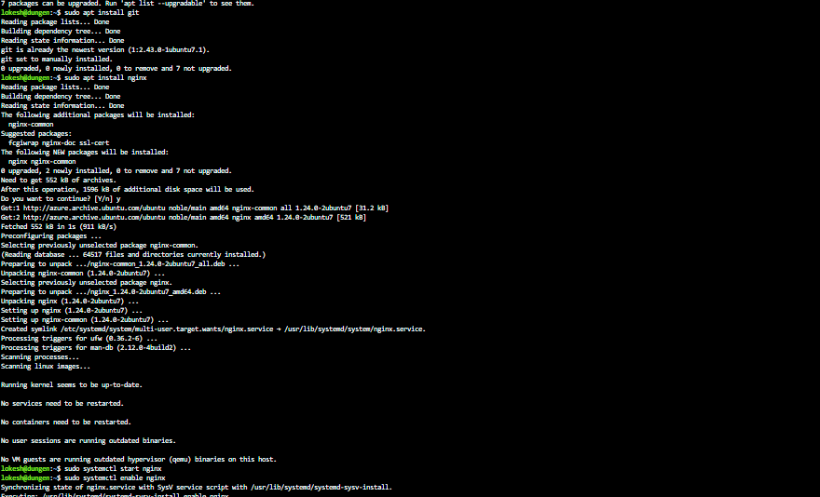

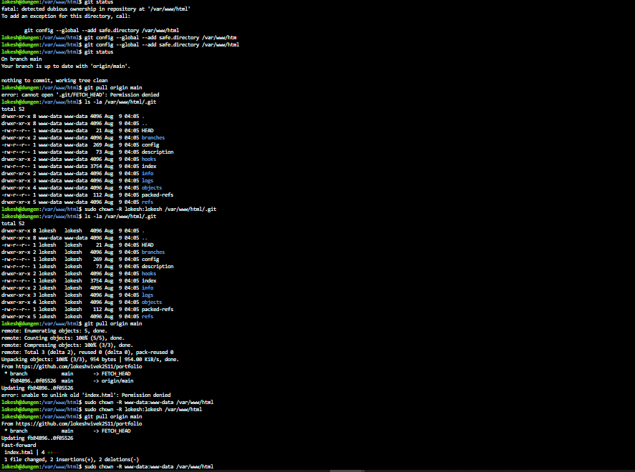

# Output:

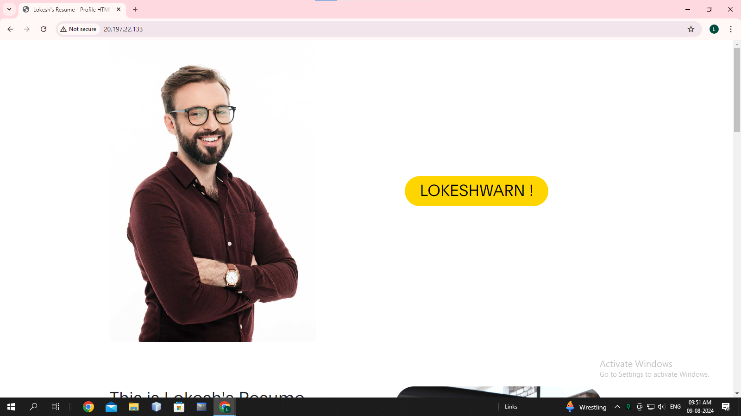





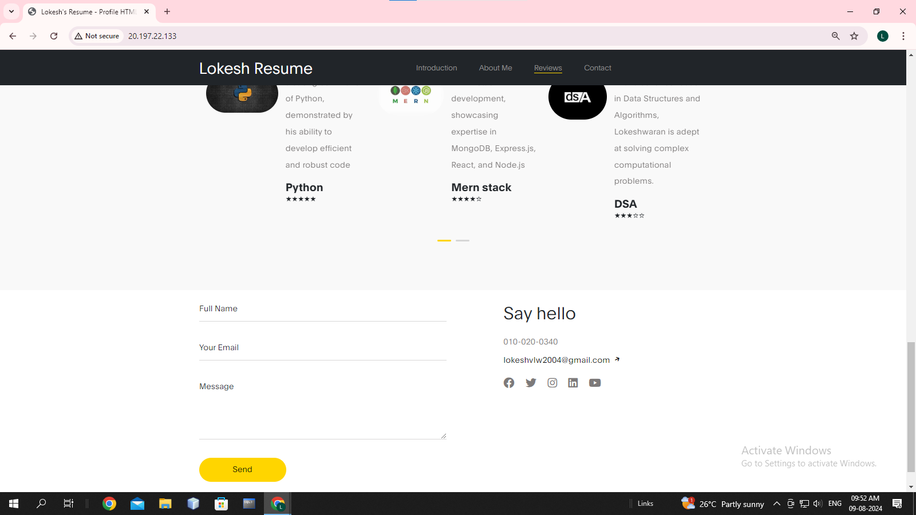

# **Creating storage using blob:**

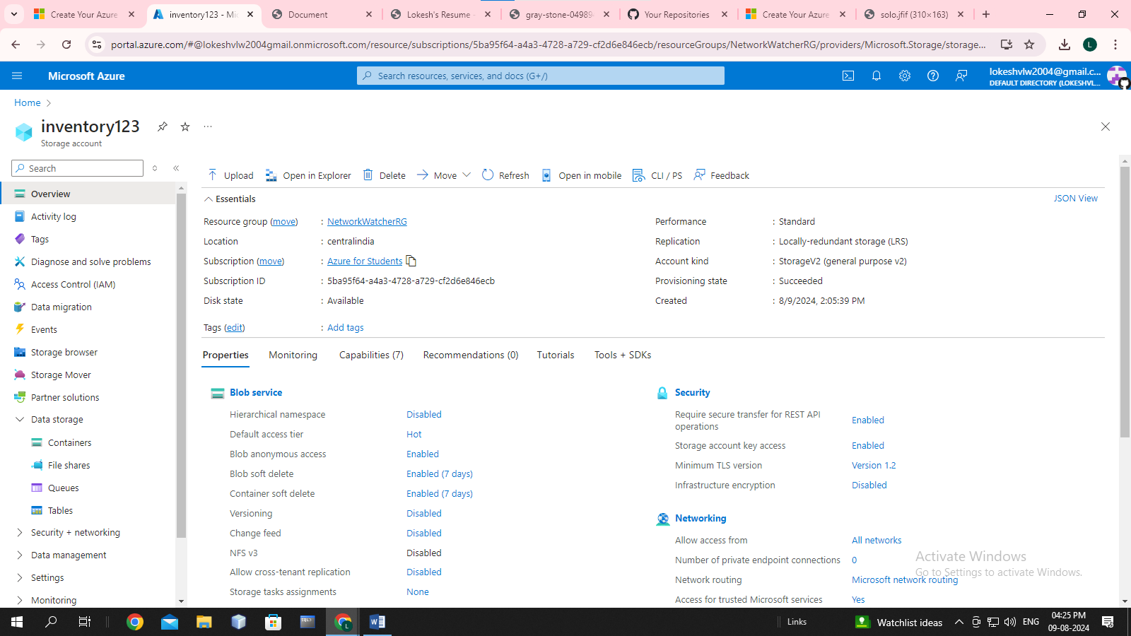

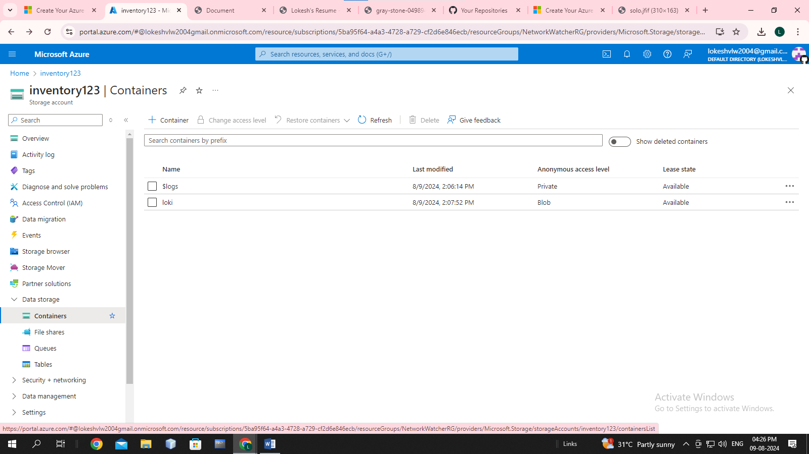

# Output:

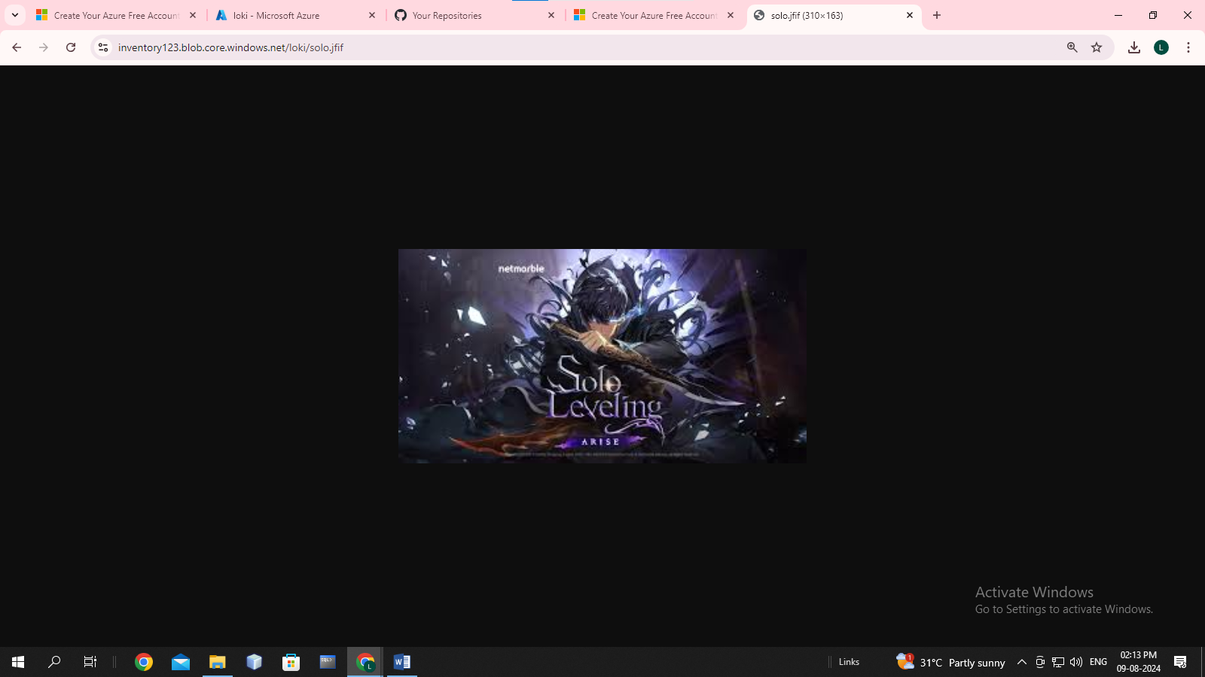

# **Url:** https://inventory123.blob.core.windows.net/loki/solo.jfif

# **Deploying directly with github:**

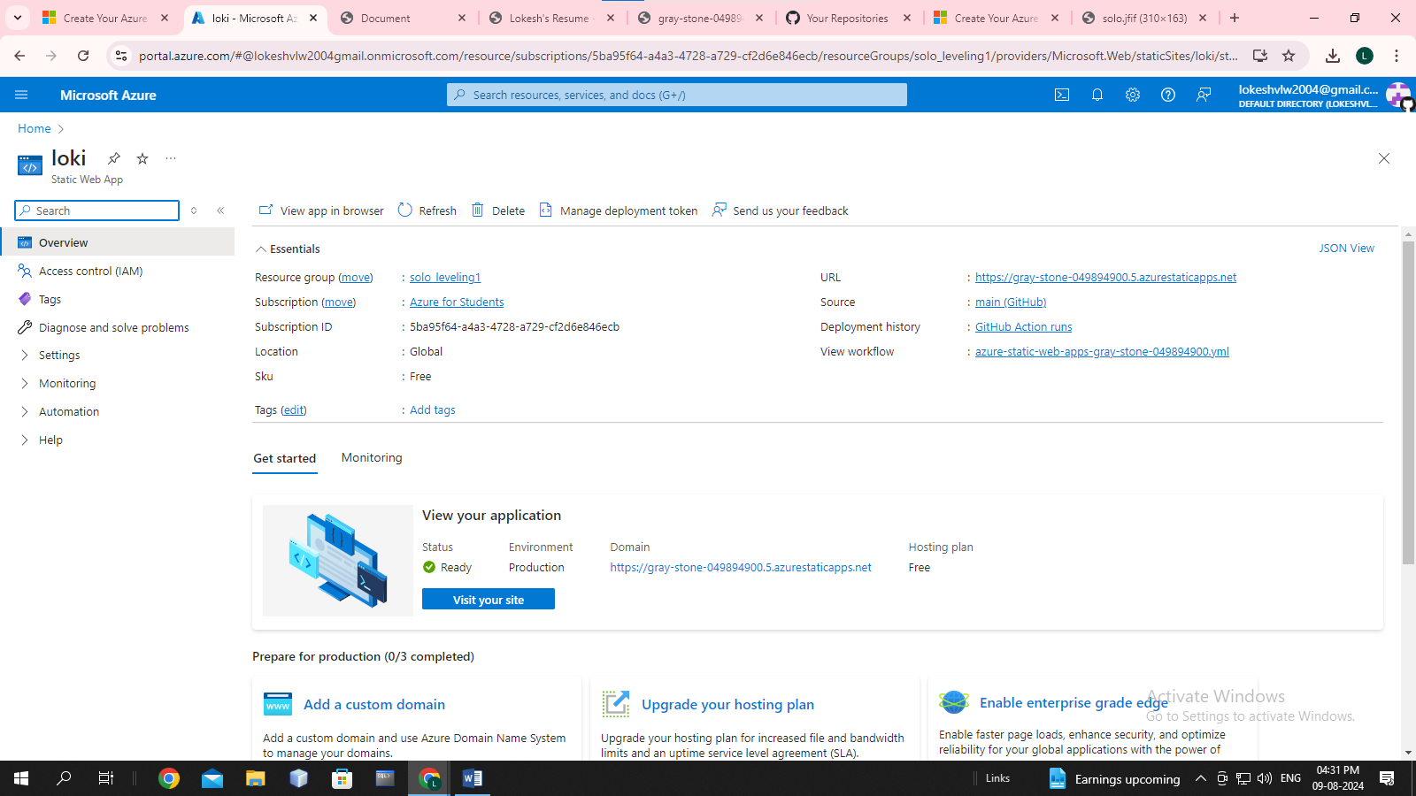

# **Url:** [https://gray-stone-049894900.5.azurestaticapps.net](https://gray-stone-049894900.5.azurestaticapps.net/)